SCREENSHOTS FOR MACHINE PROBLEM 5(PYTHON)

**SCRIPT:**

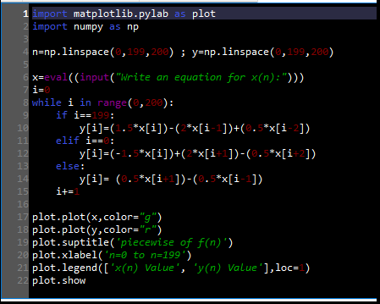

**OUTPUT1:**

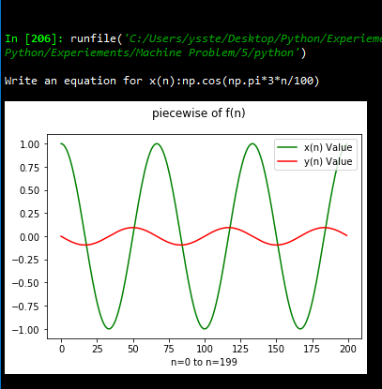

**OUTPUT2:**

